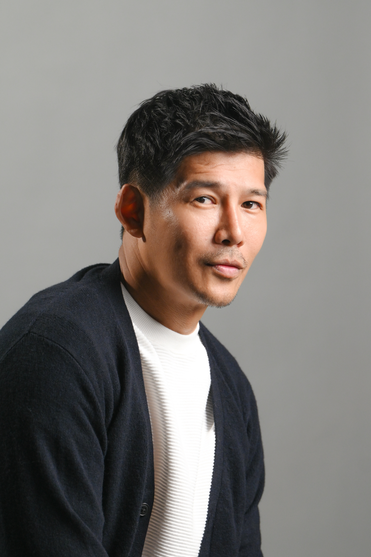
Dennis Toh 卓奕

After a 14-year hiatus, former Top 12 Singapore Star Search 2001 finalist, Dennis Toh's love for acting and modeling was reignited after reconnecting with a fellow alumnus to act in 2 church plays. Thereafter, within a short span of 5 years, Dennis has appeared in over 30 dramas and commercials. On-screen, he most recently appeared as 'Keong' on A Bridge, a four-part series commissioned by MCCY.
In the theatre scene, Dennis appeared in Four Horse Road 2020 staged by The Theatre Practice in 2020. He also produced theatre shows like Surviving Hope, Changing Shift and Catfished in 2023.
A graduate from NTU, WKWSCI, Dennis currently teaches Mass Media and Communication subjects at a few tertiary institutions in Singapore. He is the author of 101 Ways To Get Publicity. He is currently venturing his options in China.

Age: 47
Handphone: +6596566947
Email: dennistohster88@gmail.com
Height: 183cm
Weight: 78kg

Website: www.iamdennistoh.com
Instagram: www.Instagram.com/DennisTohSG
Facebook: www.Facebook.com/DennisTohSG
Master Of Mass Communications, NTU, WKWSCI, 2007

COMPETITION & TRAINING

Mediacorp Acting Class MEDIACORP 2000
Star Search Singapore Top 12 Finalists MEDIACORP 2001
AugustMan Singapore Top 12 Finalists Burda Singapore 2010
Certificate in Acting Lasalle Singapore 2016
Comedic Improvisation HCAC 2017
​Diction in Standard Mandarin Nine Years Theatre 2017
Lecoq Method Acting HCAC 2018
Where Do I Begin? Bhumi Collective 2018
Producing for the Stage
Acting Master Class by Oliver Chong The Finger Players 3-21Dec 2018
Broadway Singing Programme Intune Music June 2019
Michael Chekhov Techniques Khairul Kamsani July 2019
Meisner Technique Khairul Kamsani July 2019
Being Series with Gey Pin Ang Gey Pin Aug/Sept 2019
TEXTing Solo Jonathan Lim. Dec 2019
Being Series with Gey Pin Ang Gey Pin. Aug 2020
Seeding Lab with Jalyn Jalyn Han April 2022

TELEVISION

隨心所遇 | Featured | Bartender | MEDIACORP | 2000
Crescendo | Featured | Store Owner | Wawa | 2015
Tanglin | Featured | Doctor | Mediacorp | 2016
Last Memory | Supporting | Landlord | Student Film | 2016
Trapped Minds | Supporting | Police Officer | Reta/ Toggle | 2016
Fire Up | Featured | Reporter | Wawa | 2016
For Pat | Main | Brother | Student Film | 2016
Office Politics | Main | Office Worker | MM2 Short Film | 2016
Ang Ku Kueh | Main | Son | Student Film | 2016
Night Drive | Main | Brother | ADM Student Film | 2016
Bedwetting | Main | Participant | cIne65IV | 2016
It will never happen Here | Main | Terrorist | Monochomatic  Film | 2017
A Lonely Fish | Supporting | Father | Mediacorp | 2018
新生 | Supporting | Son | Channel 8 | 2018
Dear Neighbour | Feature | Mr Go | Channel 8 | 2019
功星计 | Feature | 浩成 | WAWA | 2019
Inside Crime Scene | Supporting | Sunny Ang | August Pictures | 2021/202
CTRL | Supporting | Boyfriend | Mediacorp | 2021
Shero | Supporting | Love Interest | Mediacorp | 2022
RED MARKING | MAIN | Father | Chong Wu | 2020
A Bridge/ Singapore Together | Main | Homeless Man | Nicky Loh | 2023
Playing Pondan | Supporting | Love Interest | Vidsee | 2022
Let Me Clean Up My room | Main | Father | Student Film | 2024
Ketchup | Main | Friend | Student Film | 2024
Portrait | Main | Emil | SG60 Film Maple Tree | 2025

MODELING

Singtel | Male Lead | Print Advertisement | 2001
NIKE | Male Lead | Print Advertisement | 2002
Eu Yang Sang | Featured | TVC | 2013
IDA | Nale Lead | TVC | 2015
KAO | Male Lead | Corporate Video | 2015
BCA | Male Lead | Corporate Video | 2015
Extra Space | Male Lead | Print Advertisement | 2015
IKEA | Featured | TVC | 2015
Thomas & Friend | Male Lead | Print/TVC | 2015
Chan Brothers | Make Lead | Outdoor Print | 2016
Manulife | Poster Boy | Print/TVC/Outdoor/Transit | 2016
Vitagen | Executive | Print/TVC | 2016
Singtel | Executive | TVC | 2016
Starhub | Executive | Corporate Video | 2016
KFC CNY | Featured Father | TVC | 2016
My Starhub APP | Male Lead | TVC | 2016
RedMart | Male Lead | Print | 2016
Bukit Sembawang | Male Lead | TVC | 2017
UBER TVC | Father | TVC | 2017
Zendic Plus | Male Lead | TVC | 2017
Dester Beer | Male Lead | TVC | 2017
Samsung QLED TV | Male Lead | TVC | 2018
Riverfront Residences | Male Lead | TVC | 2018
Wheelock Place | Father | TVC | 2018
Philips Shaver | Male Lead 2 | TVC | 2018
CNB TVC | Father | TVC | 2019
OCBC CAR LOAN | Male Lead 1 | Social Media Video | 2019
NPARK | Father | Social Media Video | 2020
NTUC FAIR PRICE | Father | Print Shoot | 2019
AVIVA Insurance | Father | TVC | 2021
PORSCHE SINGAPORE | Father | TVC | 2021
Kentucky Fried Chicken | Father | TVC | 2021
TRUST BANK | Boyfriend | Print Campaign | 2022
SGX | Main Lead | TVC | 2022
Avis Car Rental | Father | TVC | 2022
UCC Black Coffee | Businessman | TVC | 2023
Singtel Chinese New Year | Husband | TVC | 2024
National Design Council | Father | TVC | 2025
Public Transport Council | Son | TVC | 2025
SMRT | Boyfriend | TVC | 20245

THEATRE

The Search for True Love  {National Library Board, Drama Centre | Main | Ben | News String  Ministry | 2015
Who is Jesus  (Esplanade Theatre) | Supporting | Pilate | News String  Ministry | 2016
四马路  Four Horse Road | Main | Mamoru Shinozaki  Mamasan (Karayuki-san) | The Theatre Practice | 2020
Surviving Hope | Producer | Producer | The FLUX MEDIA | 2022
Changing Shift | Producer, Actor | Jackson | 海燕等人  The Etceteras | 2023
Catfished Production (Mandarin) | Co-Producer, Actor, Scriptwriter | 国强 | The FLUX MEDIA | 2023
Journey to Singapura | Actor | Durian Master (Lead) | Reverberance SG | 2025

HOSTING

MCYS Dinner & Dance | 2006
On a street in Singapore Book Launch | 2011
Sticky Presentation Book Launch | 2011
HTL Dinner & Dane | 2013
The Search for True Love Press Conference | 2015
Singapore in the 60s Book Launch | 2015
Wedding Bliss Orchard Gateway | Oct 2015
Hunt for Red Lion Press Conference | Oct 2015
HPB Healthy Lifestyle Sunshine Bakeries | Nov 2015
Scoot DFASS Gold Club Retreat Training | Nov 2015
Opto Pharm Dinner & Dance | Dec 2015
Fastacash Dinner & Dance | Dec 2015
YCK Zone 4 Christmas Event | Dec 2015
Waterview Condo Christmas Event | Dec 2015
Tour Guide Chapter Dinner & Dance | Dec 2015
Oil Gas Industries Gala Dinner ( Bintan) | Jan 2016
ASUS Dinner & Dance | Jan 2016
ASUS Reseller’s Night | Feb 2016
SEP Dinner & DANCE | JAN 2016
POMO ARTS FEST | AUG 2016
Sentosa Cove Holiday Market | Nov 2016
NTUC ADM Teambuilding Day | Oct 2017
Spectrum AV Dinner & Dance 2018 | Mar 2018

END

